Procedure to Execute the Azure Blueprints Template through Command Prompt.

1. Download Terraform.exe from Official website (<https://www.terraform.io/downloads.html>). Choose Windows and then download.
2. Create New folder in the name of Terraform in C:\ and copy and paste the already downloaded Terraform.exe in it.
3. Go the **Controlpanel**🡪**System**🡪**System** **Setting**(Left Panel)🡪**Advance**🡪**Click** **Environment** **Variables**🡪**select** “**path**”🡪**Edit**🡪**NEW**🡪**Browse**-->Choose the folder created in **Step 2.**
4. Open Command Prompt in “Administrator”.
5. To verify terraform is available in our machine. You can type “terraform“and then “**Enter**“. You can able to see the command’s available in the terraform.
6. Install azure CLI. Open the link [https://docs.microsoft.com/en-us/cli/azure/install-azure-cli-windows?view=azure-cli-latest](https://docs.microsoft.com/en-us/cli/azure/install-azure-cli-windows?view=azure-cli-latest%20)
7. Download the MSI INSTALLER and install the same.
8. Once Azure CLI installed successfully close the command prompt and Open once again in Administrator mode.
9. Based on the providers and resources, there may be a requirement to add additional terraform executable files that are available in the official website. To add them follow the below steps
10. In C:/ search for “**terraform.d**” folder.
11. Create a new folder named “**plugins**”.
12. Inside plugins folder create a sub folder “**windows_amd64**”.
13. Place all the additional executable files download into the above folder. Executable files downloading link provided below steps.
14. You need to download following providers and paste into **windows_amd64** created above.
    1. <https://releases.hashicorp.com/terraform-provider-azurerm/1.18.0/terraform-provider-azurerm_1.18.0_windows_386.zip>
    2. <https://releases.hashicorp.com/terraform-provider-external/1.0.0/terraform-provider-external_1.0.0_windows_386.zip>
    3. <https://releases.hashicorp.com/terraform-provider-tls/1.2.0/terraform-provider-tls_1.2.0_windows_386.zip>
    4. <https://releases.hashicorp.com/terraform-provider-random/2.0.0/terraform-provider-random_2.0.0_windows_386.zip>
    5. <https://releases.hashicorp.com/terraform-provider-null/1.0.0/terraform-provider-null_1.0.0_windows_386.zip>

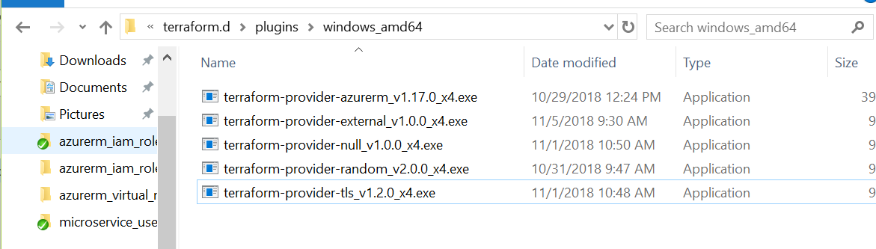

1. GOTO Command Prompt and point out the Terraform template folder (Source Folder).
2. Once poining to the source folder then Enter “terraform init”.
3. Then Enter “terraform apply”
4. Enter value is “yes”.
5. Resources will be created succesfully in Azure Portal.